Electrocardiogram (ECG) Classification Based On Dynamic Beats Segmentation

Hadeer El-Saadawy, Manal Tantawi, Howida Shedeed and M.F. Tolba  
Faculty of Computer and Information Science

Ain Shams University

Cairo, Egypt  
Hadeer_Ibrahim@cis.asu.edu.eg

**ABSTRACT**

The Electrocardiogram (ECG) has been introduced for decades as a powerful tool for diagnosing heart diseases. The majority of publications in the automatic ECG based diagnosis domain have utilized a fixed segmentation for heartbeats which doesn’t consider the changes that can occur in heart rate over time. In this paper, an automatic reliable method for diagnosing heartbeats with a new heart rate invariant segmentation procedure is proposed. The segmented heartbeats are decomposed using discrete wavelet transform (DWT). The resulting wavelet coefficients are reduced using Principle Component Analysis (PCA) and then classified using a Support Vector Machine (SVM) classifier into five main categories that represent 15 classes. Moreover, in order to increase the reliability of the proposed method, not only the overall accuracy is considered but also the average accuracy for each class. The achieved results using the MIT-BIH database for the Average Accuracy and the Overall Accuracy are 96.35% and 99.5% respectively.

**Keywords**

Electrocardiogram (ECG); Discrete Wavelet Transform (DWT); Principle Component Analysis (PCA); Support Vector Machine (SVM).

# INTRODUCTION

Permission to make digital or hard copies of all or part of this work for personal or classroom use is granted without fee provided that copies are not made or distributed for profit or commercial advantage and that copies bear this notice and the full citation on the first page. To copy otherwise, or republish, to post on servers or to redistribute to lists, requires prior specific permission and/or a fee.

*ACM PODS’09*, Providence, RI, USA.

Copyright 2008 ACM 1-58113-000-0/00/0004…$5.00.

Electrocardiogram (ECG) describes the electrical activity of the heart over time, reflecting the underlying cardio-physiology of the subject. The ECG trace shows three successive prominent waves named P, QRS and T waves. The Atria contractions (i.e. both right and left) are shown as the P wave, while, the ventricular contractions (both right and left) are shown as QRS complex. Finally the T wave reflects the electrical activity produced when the ventricles are recharging for the next contraction.

Hence, cardiac arrhythmias can be indicated by detecting changes that occur in the shape of any of the three waves [1]. The utilization of ECG in autonomous categorization of the heartbeats (i.e. Cardiac arrhythmias) is considered from the most recent fields of the research [2, 3]. Cardiac arrhythmias mean that there is an abnormal activity in the heart depending upon certain groups of conditions [4, 5].Arrhythmias have two main categories: The first one can trigger cardiac arrest and sudden death, such as tachycardia and ventricular fibrillation [6, 7]. On the other hand, the second category (our interest in this paper) needs attention but is not critically as life threatening as the first category [5].

In the literature, the heartbeats segmentation is done in a static way [5, 8, 9]. Fixed segmentation causes more than one beat to reveal in one segment in the case of high heart rate and less than one beat (truncated beat) in the case of low heart rate. Furthermore, all the existing studies [5, 8-17] have considered only the Overall Accuracy which is not realistic, since some categories have thousands of data samples while others have few data samples. Thus, the results achieved by the large categories most probably will dominate the final overall Accuracy.

In this paper, a new heart rate invariant segmentation procedure for heartbeats is introduced. Discrete wavelet transform (DWT) is applied to the segmented heartbeats and then principle component analysis (PCA) is utilized for reducing the dimension of the resulting wavelet coefficient structures. The reduced feature vectors are fed into the support vector machine (SVM) classifier to be classified into 15 classes and mapped to 5 main categories [8, 9]. The proposed method runs on ECG data from both lead 1 & lead 2 yielding two decisions for each heartbeat. Finally, the final decision is deduced using the rejection methodology [5, 8]. MIT-BIH database has been utilized for training and testing purposes and both the Overall and Average (average of the average accuracy of each category) accuracies have been considered for evaluation.

The remainder of this paper is organized as follows: Overview about the related work is provided in section 2. Section 3 discusses the proposed methodology in detail. Section 4 represents all the achieved results and finally, the conclusion and the future work are provided in section 5.

# RELATED WORK

Regarding the existing studies, the heartbeats segmentation is usually accomplished using a fixed window. In [5 , 8] the segmentation is done by taking a window of 100 samples before the R-Peak and 200 samples after it, while in [9] the window is defined by taking 100 samples before the R-Peak and 100 samples after it. Thus, heart rate changes that may result in multiple heartbeats or truncated beat in a one segment are not considered.

Moreover, Except for [5, 8, 9], most of the existing studies have considered few Arrhythmia classes. For instance, some studies [14, 15, 16] have considered only six Arrhythmia classes using Support Vector Machine (SVM) classifier and MIT-BIH database for training and testing purposes. Bulusu et al. [14], have utilized improved morphological features to classify six different Arrhythmia classes (Normal, Ventricular, Atrial, Fusion, Right and Left Bundles Branches) and they achieved an Overall Accuracy 96.35%. Daamouche et al. [15] have achieved Overall Accuracy 88.84% for classifying six different Arrhythmia classes (Normal, Atrial Premature, Ventricular Premature, Right Bundle Branch, Left Bundle Branch and Paced) using wavelet features for representing heartbeats. However, Melgani et al. [16] have achieved an Overall accuracy 93.27% for the same classes.

Other studies [10, 17] have considered only five Arrhythmia classes using also SVM classifier and MIT-BIH database for validation. Martis et al. [10] have considered five different Arrhythmia classes (Normal, Right Bundle Branch, Left Bundle Branch, Atrial Premature Contraction and Premature Ventricular Contraction) and they achieved Overall Accuracy 98.11% after comparing different approaches for feature extraction which based on principle component analysis, discrete wavelet transform and linear prediction model. On the other hand, Yazdanian et al. [17] have considered the same five classes and they have achieved Overall Accuracy 96.67% using morphological, time-domain and wavelet features.

Finally, some studies have considered less than five classes. Khazaee [18] proposes utilizing 10 morphological and two time duration features to represent each heartbeat. SVM has been considered to classify three Arrhythmia classes (Normal, Premature Ventricular Contraction and Others) and an Overall accuracy of 99.9% has been achieved using MIT-BIH database.

To summarize, the existing studies have considered fixed windows for heartbeat segmentation, few classes for discrimination and only the Overall accuracy as an evaluation measure which is not convenient in reality, because the considered categories are not equally represented in the testing data. Some categories have thousands of testing data samples while others have only few testing data samples. Thus, the results of those huge categories control the overall resulted accuracy. The aim of this paper is to resolve these crucial issues as much as possible.

# METHODOLOGY

The proposed method consists of mainly six main stages as shown in Figure 1. As mentioned in the previous section, data from both leads have been considered. Thus, the proposed method is applied on each lead separately until the last stage where the results from both leads are fused into one final decision. A detailed discussion about the utilized dataset and each stage is provided in the next sub-sections.

**Figure 1. The main steps of the proposed method.**

## Dataset

The MIT-BIH database [19] is the most used database in literature [2, 3, 4, 8, 9, 10, 14, 18] as recommended by ANSI/AAMI EC57:1998 standard [20]. This database consists of 48 records each of them is 30 minutes long and sampled with a frequency of 360 Hz. According to the ANSI/AAMI EC57: 1998 standard, there are four paced records which are not included in the classification. Therefore, in this study, the experiments were carried out using 44 records only.

Each record has an annotation file which contains the annotations of all the beats and positions of all the R-Peaks in the record. Hence, these annotations and positions have been used as the ground truth for training and testing.Moreover, ECG data from both lead1 and lead2 have been considered.

In this study, the training and testing division percentages mentioned in [5] have been followed, where the training set consists of approximately 13% of the total number of beats from the Normal Class, 40% of total number of beats from all classes having larger amounts of data and 50% of the total number of beats from all classes having a small amount of data as shown in Table 1.

**Table 1. The Percentage of training and testing sets used in the experiments**

|  |  |  |  |
| --- | --- | --- | --- |
| Heartbeat Type | Annotation | Training Ratio | Training Beats Number |
| Normal “NOR” | N | 13% | 9753 |
| Left Bundle Branch Block “LBBB” | L | 40% | 3229 |
| Right Bundle Branch Block “RBBB” | R | 40% | 2902 |
| Atrial Premature Contraction “APC” | A | 40% | 1019 |
| Premature Ventricular Contraction “PVC” | V | 40% | 2852 |
| Paced “PACE” | \ | 40% | 2810 |
| Aberrated Atrial Premature “AP” | a | 50% | 75 |
| Ventricular Flutter Wave “VF” | ! | 50% | 236 |
| Fusion of Ventricular and Normal “VFN” | F | 50% | 401 |
| Blocked Atrial Premature “BAP” | x | 50% | 97 |
| Nodal (Junctional) Escape “NE” | j | 50% | 115 |
| Fusion of Paced and Normal “FPN” | f | 50% | 491 |
| Ventricular Escape “VE” | E | 50% | 53 |
| Nodal (Junctional) Premature “NP” | J | 50% | 42 |
| Atrial Escape “AE” | e | 50% | 8 |
| Unclassifiable “UN” | Q | 50% | 7 |
| Total | 16 Classes | 21.89% | 21280 |

Then according to the ANSI/AAMI EC57: 1998 standard, the classes in Table 1 are mapped into five main categories as shown in Table 2.

**Table 2. The five main categories according to the ANSI/AAMI EC57: 1998 standard.**

|  |  |
| --- | --- |
| **ANSI/AAMI Classes** | **MIT-BIH Classes** |
| **N** | NOR, LBBB, RBBB, AE, NE |
| **S** | APC, AP, BAP, NP |
| **V** | PVC, VE, VF |
| **F** | VFN |
| **Q** | FPN, UN |

## Preprocessing

The aim of this stage is to reduce the noise by applying the Butterworth Band pass filter 0.5Hz-45Hz to remove the unwanted low and high frequencies while preserving the ECG spectra. Figure2 shows a single normal beat before and after noise removal.

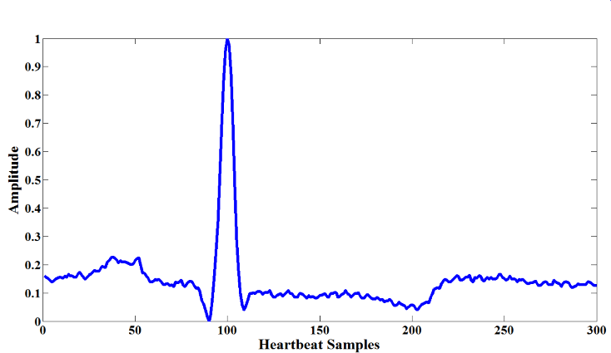

**(a)**

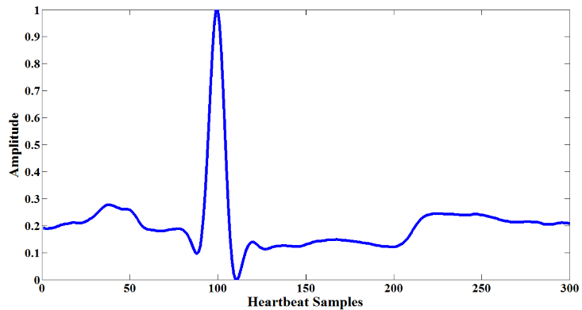

**(b)**

**Figure 2. Normal beat a) before b) after preprocessing.**

## Beats Segmentation

Each ECG trace (record) is segmented into ECG heartbeats. Each heartbeat must encompass the three complex waves P, QRS and T. In the literature, due to the difficulty in detecting the beginning and the end of each heartbeat, a fixed segmentation has been considered by taking a definite number of samples before and after each R peak [5, 8, 9]. However, this strategy ignores the effect of heart rate changes. As the heart rate increases (decreases), the one segment may include more (less) than one heart beat which by its role, may violate the later extracted features. Thus, in this study, a new beat segmentation is introduced where the number of samples considered before and after each R peak is counted according to the duration between the current R peak and the previous R ( RR previous) and the duration between the current R peak and the next R ( RR next). The RR interval is usually considered as heartbeat duration since it includes all three complex waves. Thus, when the heart rate increases (decreases), correspondingly the RR duration decreases (increases).

Hence, the following equations have been evaluated. Besides for comparison, fixed segmentation has beenapplied by taking 100samples before the R-Peak and 200 samples after the R-Peak [5, 8].

$Before Rpeak=\frac{1}{3}*\frac{RR previous + RRnext }{2}$ (1)

$After Rpeak=\frac{2}{3}*\frac{ RR previuos+ RRnext}{2}$ (2)

$Before Rpeak=0.4*\frac{RR previous+RRnext }{2}$ (3)

$After Rpeak=0.6*\frac{RR previous+RRnext}{2}$ (4)

$Before Rpeak=\frac{1}{3}*Max\left(RR previous, RRnext\right)$ (5)

$After Rpeak=\frac{2}{3}*Max(RR previous, RRnext)$ (6)

The reason behind choosing the duration before the R peak is always nearly half the duration taken after it, is that naturally the distance between the beginning of the P wave and the R-Peak is approximately half the distance between the R-Peak and the end of the T wave [21]. Figure 4 (a-c) shows the segmentation using the mentioned equations.

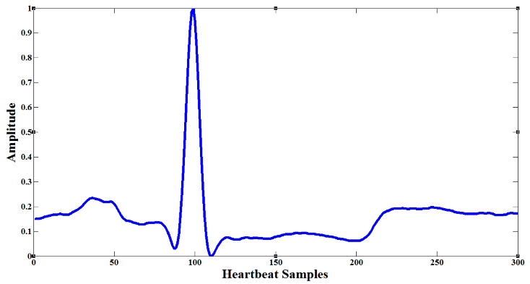

**(a)**

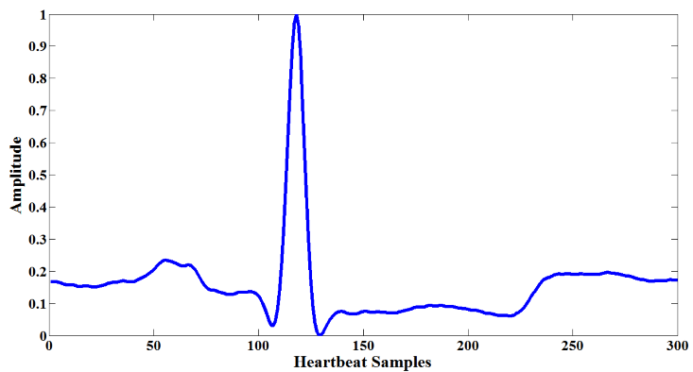

**(b)**

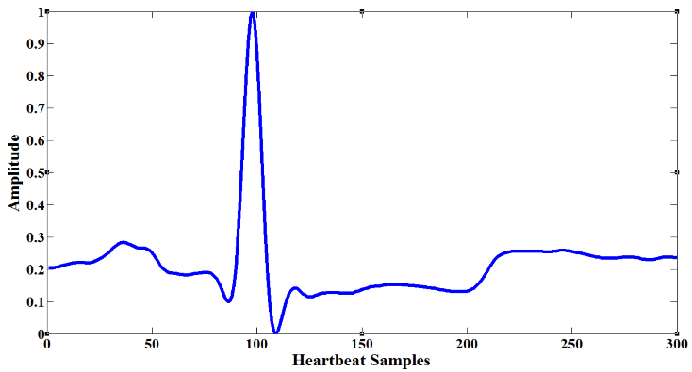

**(c)**

**Figure 6. A segmented heartbeat using a) first, second b) third, fourth c) fifth, sixth equations.**

## Features Extraction

Wavelet transform (WT) has been applied for its efficiency as in the case of a non-stationary signals such as ECG [5]. Different mother wavelet families such as Biorthogonal, Haar and Daubechies have been evaluated to get the best description for the characteristics of the QRS wave.

## Features Reduction

After the extraction of features in the previous step, a reduction step is needed since the resulting wavelet coefficients are of a high dimension and may include information irrelevant for the task in hand. PCA is applied to find a subspace which preserves most of the information context of the original feature space. The optimum number of PCA components has been found empirically during the experiments.

## Classification

SVM is a binary classifier described by Vapnik [22] that separates the classes by building a hyper plan between them. Initially, SVM is used to classify 2 classes. However, recently there are new methods that have been developed in order to satisfy the classification of more than 2 classes. In this study, SVM has been used to classify 15 classes mapped to 5 main categories as shown before in Table2.

Let N equal the number of data samples, each data sample represents a features vector and its ground truth *{*(**x***i, yi*)*, i* = 1*, . . . , N}*. By using the training set, a decision function as mentioned in equation (7) can be constructed to be used later in the testing

f (x) = sign (∑ αi yi K (xi, x) + b) (7)

Where αi is the Lagrange multiplier for each data sample in the training and K () is the kernel function [5, 8].

## Lead1 and Lead2 Fusion

After applying the proposed method on both Lead1 and Lead2 signals separately, the results from the both leads are fused to improve the performance of the proposed classifier. In this study, the rejection method [5, 8] has beenchosen. The rejectionmethod is as follows: If the classification result of the same beat from lead1 and lead2 are not the same, the rejection method neglects this beat for a further classification that is be done manually by the doctor but if the classification result is the same in both lead1 and lead2, the rejection method will take this beat into consideration. The penalty of this method is in the percentage of the rejected beats which should be minimized as much as possible.

# EXPERIMENTAL RESULTS

As mentioned in section 1, the proposed method has been evaluated using two measures. First, the measure considered by the literature, the Overall Accuracy. Second, the average accuracy by which the same impact is given to each category on the overall average result. The two measures are computed as shown in equation (8) and equation (9):

$Overall Accuracy= \frac{Number Of Correctly Classified Beats In All Categories}{Total Number Of All Beats}$ (8)

$Average Accuracy=\frac{\sum_{1}^{5}{Accuracy Of Each Category}}{5}$ (9)

Where the accuracy of each category is computed as shown in equation (10):

$Accuracy Of Each Category=\frac{Number Of Correctly Classified Beats In This Category}{Number Of All Beats In This Category}$ (10)

The proposed method is applied first on the data from lead 1. The segmented heartbeats using the fixed window and the proposed equations are decomposed by different mother wavelets. The experiments revealed the superiority of the db8 mother wavelet with four levels of decomposition. The ECG spectra is concentrated between .5 Hz and 40 Hz which corresponds to the coefficients of D3 (details of level 4), D4 (details of level 4) and A4 (approximation of level 4). Thus, a vector of 114 coefficients (i.e. 32 from A4, 32 from D4 and 50 from D3) is utilized to describe each heartbeat. Table 3 shows the achieved results with different segmentation strategies before applying the PCA for dimension reduction and with using Gaussian kernel for the SVM classifier. The results achieved by the third equation are approximately the same as those achieved by the fixed window. However, after applying the PCA for reducing the dimension for feature vectors, the results achieved by equation 3 are higher than over the full range of PCAs utilized as shown in figure 7 (a & b).

**Table. 3. Results using different segmentation equations.**

|  |  |  |  |  |
| --- | --- | --- | --- | --- |
|  | **Fixed window** | **First Equation** | **Second Equation** | **Third Equation** |
| **N** | 95.73% | 97.05% | 93.69% | 96.34% |
| **S** | 71.62% | 68.16% | 65.17% | 71.0996% |
| **V** | 95.01% | 93.46% | 90.13% | 92.12% |
| **F** | 84.54% | 84.29% | 89.28% | 85.04% |
| **Q** | 83.17% | 79.16% | 75.75% | 86.77% |
| **Overall Accuracy** | 86.01% | 84.42% | 82.8% | 86.27% |
| **Average Accuracy** | 95.04% | 96.07% | 92.75% | 95.46% |

**(a)**

**(b)**

**Figure 7. The overall and average accuracies as a function of the number of PCAs a) using fixed window and b) using equation 3.**

Moreover, the best results are achieved using 18 PCAs. Table 4 shows the accuracy of each category using 18 PCAs with fixed window and third equation. It is clear that by using the proposed equation, the accuracy of all categories is higher than that achieved using fixed window with an average increase of 2 %. This result can be interpreted by the fact that MIT-BIH doesn’t contain high variations in heart rates that can cause degradation in the results using the fixed window segmentation. In addition, the data is partitioned as in literature according to class oriented methodology [8, 9], where data from the same records may exist in both the training and testing sets, which by its role, decreases the chance of significant heart rate variation. Thus, greater improvement is expected when another dataset with high heart rate variations along with another methodology for partitioning data that guarantees that records considered for training will be completely different from those for testing.

**Table 4. Best results using 18 PCAs.**

|  |  |  |
| --- | --- | --- |
|  | **Without Equation** | **Third Equation** |
| **N** | 97.63% | 97.58% |
| **S** | 91.23% | 93.095% |
| **V** | 96.72% | 96.83% |
| **F** | 82.54% | 86.03% |
| **Q** | 91.58% | 93.19% |
| **Overall Accuracy** | 91.94% | 93.35% |
| **Average Accuracy** | 97.37% | 97.39% |

The proposed method is applied on data from lead2 using the same parameters yielding overall and average accuracies equal to 90% and 96.2% respectively. After fusion using the rejection method, the results increased to **96.35%** average Accuracy, **99.5%** Overall Accuracy and the Rejection Penalty equals **4.58%**. Table 5 summarizes a comparison with the existing studies that shows that the proposed method provides comparable results and as shown, none of the existing studies have considered the average accuracy.

**Table 5. Comparison with the existing studies.**

|  |  |  |  |
| --- | --- | --- | --- |
|  | **N P. Joshi\1 [8]** | **Roshan [9]** | **The Proposed Method** |
| **# Of Classes** | 15 classes mapped to 5 categories | 15 classes mapped to 5 categories | 15 classes mapped to 5 categories |
| **Dataset Used** | MIT-BIH | MIT-BIH | MIT-BIH |
| **Beats Segmentation** | 100 samples before R-Peak and 200 samples after | 100 samples before R-Peak and 100 samples after | Third Equation |
| **Features Extracted** | -RR-Interval  -Independent  Component Analysis  -Wavelet Transform | -QRS Detection using Pan Tompkins[23]  -Wavelet Transform | Wavelet Transform |
| **Reduction Method** | Principle Component Analysis | Independent Component Analysis | Principle Component Analysis |
| **Classifier** | Support Vector Machine | Probabilistic Neural Network | Support Vector Machine |
| **Fusion Method** | Rejection Method | -- | Rejection Method |
| **Overall Accuracy** | 99% | 99.28 | 99.5% |
| **Average Accuracy** | -- | -- | 96.35% |

# CONCLUSIONS AND FUTURE DIRECTIONS

To conclude, an automatic method has been developed to classify different heartbeats into 15 classes mapped to five main categories. The proposed method provides a new strategy for heartbeat segmentation which considers heart rate changes over time (equation 3). The Db8 mother wavelet has been successfully utilized for decomposing the segmented beats into four levels. 114 coefficients fromlevel 3 and 4 are considered as features and reduced using PCA into 18 components. Thereafter, thereducedfeature vectors are fed into SVM for classification. Finally, the results achieved from the two leads (lead 1& 2) are fused to provide the final decision. A 99.5 % overall accuracy and a 96.35% average accuracy are achieved by using the MIT-BIH database. Furthermore, to overcome the drawbacks previously mentioned on MIT-BIH database, it is aimed to have a database with high heart rate variations and to consider subject oriented methodology, where testing is accomplished using records completely different from those utilized for training, in order to give more evidence on the efficiency of the proposed method.

# REFERENCES

1. ManalTantawi, Kenneth Revett, Abdel-Badeeh Salem, M. FahmyTolba, “Electrocardiogram (ECG): A New Burgeoning Utility for Biometric Recognition”, in Bio-inspiring Cyber Security and Cloud Services: Trends and Innovations Intelligent Systems Reference Library Volume 70, 2014, pp 349-382.
2. G. D. Clifford, F. Azuaje, and P. McSharry, Advanced methods and tools for ECG data analysis: Artech house London, 2006.
3. Hassan Yazdanian, AshkanNomani and Mohammad Reza Yazdchi, Machine learning on-a-chip: A high-performance low-power reusable neuron architecture for artificial neural networks in ECG classifications: Conference on Biomedical Engineering, 2013.
4. K. Robert and E.C. Colleen, Basis and Treatment of Cardiac Arrhythmias, 1st ed. New York: Springer-Verlag, 2006.
5. Can Ye, B. V. K. Vijaya Kumar and Miguel Tavares Coimbra, Heartbeat Classification Using Morphological and Dynamic Features of ECG Signals: IEEE TRANSACTIONS ON BIOMEDICAL ENGINEERING, 2012.
6. V. X. Alfonso and J. Tompkins, “Detecting ventricular fibrillation,” IEEE Trans. Biomed. Eng., vol. 54, no. 1, pp. 174–177, Jan. 2007.
7. K. Minami, H. Nakajima, and T. Toyoshima, “Real-time discrimination of ventricular tachyarrhythmia with Fourier-transform neural network,” IEEE Trans. Biomed. Eng., vol. 46, no. 2, pp. 179–185, Feb.1999.
8. N P. Joshi\1,Shweta A.Tambe1, P.S. Topannavar11Scholar, ICOER, Pune, India, Morphological & Dynamic Feature Based Heartbeat Classification: International Journal of Engineering Research and General Science, 2014.
9. Roshan Joy Martis a,∗, U. Rajendra Acharya a,b, Lim ChooMin a, ECG beat classification using PCA, LDA, ICA and Discrete Wavelet Transform: Biomedical Signal Processing and Control, 2013.
10. Roshan Joy Martis, U. Rajendra Acharya, K.M. Mandana, A.K. Ray and ChandanChakraborty, Application of principal component analysis to ECG signals for automated diagnosis of cardiac health: Expert Systems with Applications 39, 2012.
11. S.Osowski, L.T.Hoa and T.Markiewic,“ Support vector machine-based expert system for reliable heartbeat recognition” IEEE Trans. Biomed. Eng., vol. 51, no. 4, pp. 582–589, Apr. 2004.
12. G.deLannoy, D.Francois, J.Delbeke and M.Verleysen, “Weighted conditional random fields for supervised inter patient heartbeat classification”, IEEE Trans. Biomed. Eng., vol. 59, no. 1, pp. 241–247, Jan. 2012.
13. M. Lagerholm, C. Peterson, G. Braccini, L. Edenbrandt, and L. Sornmo, “Clustering ECG complexes using Hermite functions and self-organizing maps,” IEEE Trans. Biomed. Eng., vol. 47, no. 7, pp. 838–848, Jul. 2000.
14. S. C. Bulusu, M. Faezipour, V. Ng, M. Nourani, L. S.Tamil, and S. Banerjee, “Transient ST-segment episode detection for ECG beat classification,” in Life Science Systems and Applications Workshop.
15. A. Daamouche, L. Hamami, N. Alajlan, F. Melgani, A wavelet optimization approach for ECG signal classification, Biomedical Signal Processing and Control 7 (4) (2011) 342–349.
16. F. Melgani, Y. Bazi, Classification of electrocardiogram signals with support vector machines and particle swarm optimization, IEEE Transactions on Information Technology in Biomedicine 12 (September (5)) (2008) 667–677.
17. Hassan Yazdanian, Ashkan Nomani and Mohammad Reza Yazdchi, “Autonomous Detection of Heartbeats and Categorizing them by using Support Vector Machines”, IEEE, 2013.
18. Ali Khazaee, “Combining SVM and PSO for PVC Detection”, International Journal of Advances in Engineering Sciences Vol.3, Issue 4, October, 2013.
19. MIT-BIH Arrhythmias Database. [Online]. Available: <http://www.physionet.org/physiobank/database/mitdb/>.
20. Testing and Reporting Performance Results of Cardiac Rhythm and ST Segment Measurement Algorithms, ANSI/AAMI EC57:1998 standard, Association for the Advancement of Medical Instrumentation, 1998.
21. ECG Medical reference: <http://en.ecgpedia.org/>.
22. V. N. Vapnik, The Nature of Statistical Learning Theory... New York: Springer-Verlag, 1995.
23. J. Pan, W.J. Tompkins, A real-time QRS detection algorithm, IEEE Transactions on Biomedical Engineering BME-32 (March (3)) (1985) 230–236.